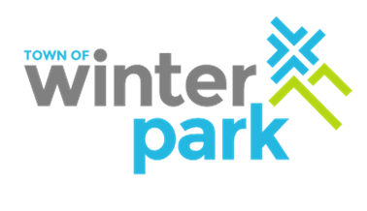Winter Park Transit Advisory Committee

**Date:**  June 7, 2021

**Time:** 4:00pm

**Location:** Winter Park Town Hall, Council Chambers or ZOOM

**Meeting Agenda:**

1. Public Forum (Comments not related to agenda items, up to 3 minutes per person)
2. Updates/Review
3. 2021/2022 Red Line Extension to Friendship Drive
   * Public Comment
   * Vote to approve/deny service request to extend the Red Line through Friendship Drive adding an additional 4 stops
4. New Business
5. Adjourn